

Ho Chi Minh City, May 12nd, 2021

# Overview

## Introduction

The Vegetarian Ordering System is a platform which connects vegans who want to have quality meals at home, and home-cooks, who want to spread the joy of cooking and spread the vegan spirit to others people. The system is expected to allow registered customers to place an order on the platform; the home-cook can create their own menu on the platform.

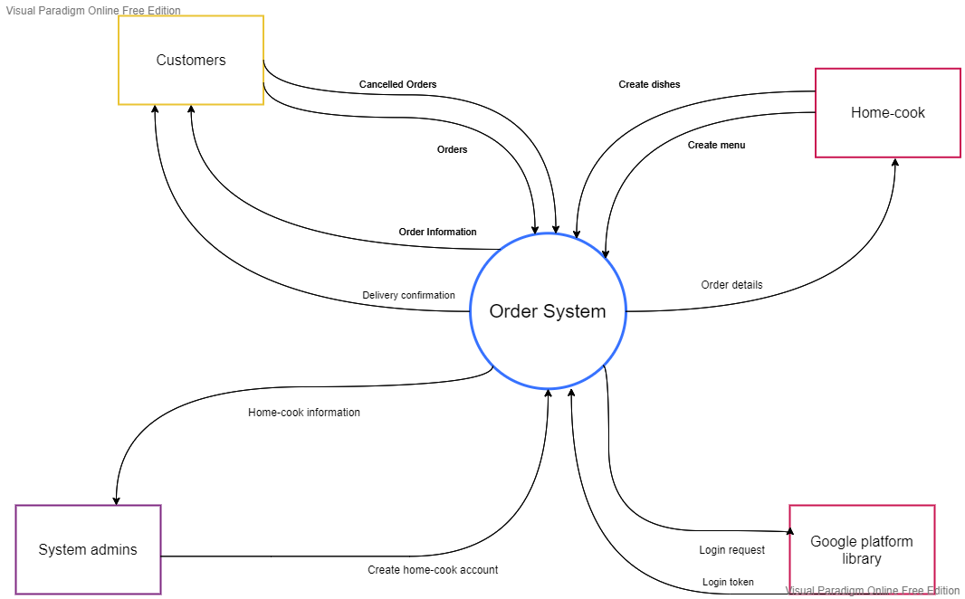

## System Functions

### Screen flows



### Screen details

|  |  |  |  |
| --- | --- | --- | --- |
| **#** | **Feature** | **Screen** | **Description** |
| 1 | Login | Login | This is the screen where user will log in |
| 2 | Register | Register | The place where new user will create their new account |
| 3 | Get list of dishes by menu | Home | A list of available menus and dishes will be displayed |
| 4 | Get user’s profile | User Profile | Detailed information of users wil be displayed |
| 5 | Update user’s profile | Edit Profile | A form where user can edit their personal information |
| 6 | Get list of home-cook | Home-cook management | A list of available home-cook is displayed |
| 7 | Create a home-cook account | Create Home-cook | A form where admin can create a new account for home-cook |
| 8 | Disable a home-cook account | Confirmation of disability | A pop-up box to confirm whether to disable the selected account or not |
| 9 | Get list of orders | List Order | A list of past orders by current user |
| 10 | Get detailed order | Order Details | Detailed information of a specific order |
| 11 | Create a new order | Create Order | A form where user can create a new order |
| 12 | Create a dish | Create Dishes | A form where home-cook can add a new dish |
| 13 | Edit a dish | Edit Dishes | A form where home-cook and update existed dish |
| 14 | Get list of Menus | List Menu | A list of menus created by home-cook |
| 15 | Edit a Menu | Edit Menu | A page where home-cook can edit existed menu |
| 16 | Delete a Menu | Delete Menu | A pop-up confirmation box whether to delete the Menu or not |
| 17 | Create a Menu | Create Menu | A page where Home-cook can create a new Menu |

### User authorization

|  |  |  |  |  |
| --- | --- | --- | --- | --- |
| **Screen** | **Unauthenticated user** | **Customer** | **Admin** | **Home-cook** |
| Login | X |  |  |  |
| Register | X |  |  |  |
| Home |  | X | X | X |
| Get list of available dishes | X | X |  |  |
| Get list of home-cooks |  |  | X |  |
| Menu management |  |  |  | X |
| Dish management |  |  |  | X |
| Create a new order |  | X |  |  |
| User Profile |  | X | X | X |
| View user’s profile |  | X | X | X |
| Update Profile |  | X | X | X |
| Edit user’s profile |  | X | X | X |
| Menu management |  |  |  |  |
| Update |  |  |  |  |
| Delete Data |  |  |  |  |
| … |  |  |  |  |

### Non-screen functions

## Common requirements

* Users must login before placing an order.
* Users must place an order 12h in advanced.
* The customers must perform the transaction before having the order prepared
* A menu must contain at least three dishes

# Function requirements